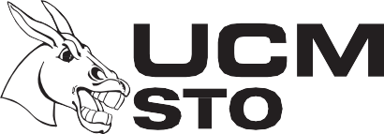
University Store
The Crossing
114 W. South St., Suite 110

660-543-4370 800-330-7698
Web: www.ucmbookstore.com email: ucmbookstore.ucmo.edu

Textbook Packing List
Date _____________ Student #______________ Phone______________________ Cell______________________
Name Email
Address
City/State/Zip
BuyBack Books: Please accept the following book(s) for buyback consideration, during the next scheduled buyback. The current value for the book(s), if any, will be applied to my UCM account.
Author | Title | ISBN # | Value
 |  |  | Store Use Only
Rental Return Books: Total Value
Author | Title | SERIAL #

Should the book(s) have no value during TEXTBOOK BUYBACK, please check your preference:
Mail book(s) to me at my expense. ($10 for the first book, $1 for each additional book)
Recycle/donate book(s) with no value.

For office use only

1st Contact Employee’s initials

2nd Contact Employee’s initials
UCM 041520

